APPENDIX 1

**Intelligent Vehicle Parking**

**MID TERM REPORT**

***by***

**Soumya Reddy**

**Roll Number:28**

**Section:K18TG**

**Morla Sri Harsha**

**Roll Number:06**

**Section:K18TG**



**Department of Intelligent Systems**

**School of Computer Science Engineering**

**Lovely Professional University, Jalandhar**

**April-2020**

APPENDIX 2

**Student Declaration**

This is to declare that this report has been written by me/us. No part of the report is copied from other sources. All information included from other sources have been duly acknowledged. I/We aver that if any part of the report is found to be copied, I/we are shall take full responsibility for it.

Sri Harsha Morla

Roll Number:06

Reddy Soumya

Roll Number:28

Place:Lovely Professional University

Date:April/07/2020

APPENDIX 3

**TABLE OF CONTENTS**

**TITLE PAGE NO.**

1. **INTRODUCTION…………………………………………………………… 05**
2. **CONCRETE GOALS AND OBJECTIVES:…………………………….06**
3. **OUTCOME OF PROJECT…………………………………………………06**
4. **CODE TO IMPLEMENT INTELLIGENCE VEHICLE PARKING SYSTEM:**

**……………………………07**

1. **DESCRIPTION OF THE PROJECT……………………………………….11**
2. **IMPLEMENTATION OF THE PROJECT……………………………….13**
3. **DESCRIPTION OF WORK DIVISION………………………………….16**
4. **TECHNOLOGIES AND FRAMEWORK TO BE USED……………….16**

APPENDIX 4

BONAFIDE CERTIFICATE

Certified that this project report” INTELLIGENT VEHICLE PARKING ” is the bonafide work of “REDDY SOUMYA,MORLA SRI HARSHA”who carried out the project work under my supervision.

Signature of the Supervisor:

Name of supervisor:

Academic Designation:

ID of Supervisor:

Department of Supervisor:

**INTRODUCTION:**

**Parking in major cities, particularly with dense traffic, directly effects the traffic flow and people’s life.**

**We introduce a new smart parking system that is based on intelligent resource allocation. In today’s life, parking of vehicle everyone needs. Be it in Malls, Cinemas, nearby Shops etc.**

**We propose an idea which can helps to solve the problem of parking allotment and parking area of the vehicle.**

**Everyone wants to park his\her vehicle safely and under security. So parking system has to provide facility to coming user and safely park his\her car.**

**Studies have shown that in many places drivers often spend over 20 min looking for parking, contributing to as much as 30% of the total traffic.**

**We present Smart Park system that reduces the effort of the drivers.**

**CONCRETE GOALS AND OBJECTIVES:**

**1. The main objective of this system is to provide easy parking that can save time and traffic.**

**2. If parking is available then user can reserve that parking through Application. So, Driver can easily park his car without facing any problem.**

**3. If parking is not available then the user is notified the same rather wasting his time.**

**4. The cost for each type of vehicle and number of parking slots are generic (that is user gives input at run time) so can be used at different parking places.**

**OUTCOME OF PROJECT:**

**The project creates an intelligent vehicle parking system which saves the time and efforts of drivers.**

**Based upon the availability of parking slots the system generates and updates the status of parking availability.**

**CODE TO IMPLEMENT INTELLIGENCE VEHICLE PARKING SYSTEM:**

**print('\t\tWelcome to AI parking')**

**car=input("Enter Car price for parking: ")**

**car=int(car)**

**bike=input("Enter Bike price for parking: ")**

**bike=int(bike)**

**truck=input("Enter Truck price for parking: ")**

**truck=int(truck)**

**bicycle=input("Enter Bicycle price for parking: ")**

**bicycle=int(bicycle)**

**bus=input("Enter Bus price for parking: ")**

**bus=int(bus)**

**maxx=input("Enter Maximum Parking Slots: ")**

**print('\n******')**

**maxx=int(maxx)**

**total=0**

**tcar=pcar=tbike=pbike=ttruck=ptruck=tbicycle=pbicycle=tbus=pbus=tslot=0**

**tslot=maxx**

**while maxx:**

**print(f'Total Slots are {tslot}\t\tFree Slots are {maxx}\n')**

**vehicle=input("which vehile you want to park?\nEnter 1 for Car\nEnter 2 for Bike\nEnter 3 for Truck\nEnter 4 for Bicycle\nEnter 5 for Bus\nEnter 6 to view record \nEnter 7 to delete record\n")**

**print('\n*****')**

**vehicle=int(vehicle)**

**if vehicle==1:**

**total+=car**

**tcar+=1**

**pcar+=car**

**elif vehicle==2:**

**total+=bike**

**tbike+=1**

**pbike+=bike**

**elif vehicle==3:**

**total+=truck**

**ttruck+=1**

**ptruck+=truck**

**elif vehicle==4:**

**total+=bicycle**

**tbicycle+=1**

**pbicycle+=bicycle**

**elif vehicle==5:**

**total+=bus**

**tbus+=1**

**pbus+=bus**

**elif vehicle==6:**

**print(f'Total Cars:{tcar}\t\tCars total price:{pcar}\nTotal Bikes{tbike}\t\tBikes total price:{pbike}\nTotal trucks:{ttruck}\t\tTrucks total price:{ptruck}\nTotal Bicycle:{tbicycle}\t\tBicycles total price:{pbicycle}\nTotal Bus:{tbus}\t\tBusses total price:{pbus}\n')**

**print('\n******')**

**maxx+=1**

**elif vehicle==7:**

**tcar=pcar=tbike=pbike=ttruck=ptruck=tbicycle=pbicycle=tbus=pbus=0**

**maxx=tslot+1**

**else:**

**print('Sorry, please Select from the above................')**

**maxx-=1**

**if maxx==0:**

**print('Slots are Full')**

**print(f'total price for parking vehicles is {total}')**

**DESCRIPTION OF THE PROJECT:**

**1. The system offers the user to enter the availability of the parking slots.**

**2. It also prompts the user to enter cost applicable for each type of vehicle.**

**3. It prompts the user to enter number the type of vehicle to be parked (like bike,car,truck,bus,car).**

**4. The system displays whether there is parking slot available or not.**

**5. If the parking slot is available for the vehicle then success message is displayed and the number of available slots is decreased by 1.**

**6. If parking slot is not available then failure message is displayed.**

**7. The system updates the number of parking slots available when the vehicle leaves the parking slot.**

**8. Hence at every point of time when vehicle is parked or vacates the parking slots the number of available slots is updated.**

**9. As the number of vehicles parked increases, the available slots decreases and when the number of vehicles vacating the parking area increases, the available slots increases.**

**IMPLEMENTATION OF THE PROJECT:**

1. **The sytem prompts for price applicable for each type of vehicle.**

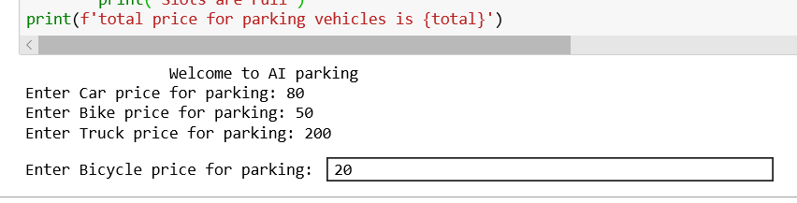

1. **The system prompts for total number of parking slots.**

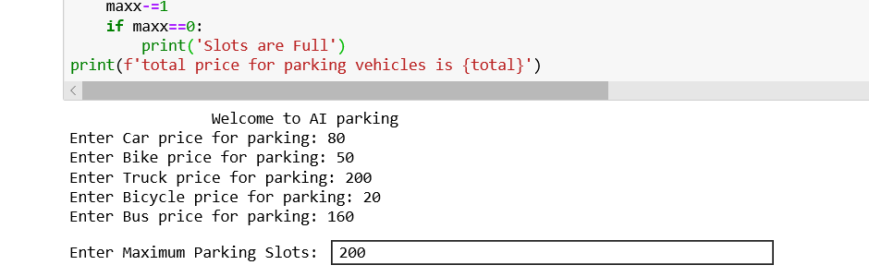

1. **The system prompts for vehicle type to be parked and updates the number of available slots and displays the same.**

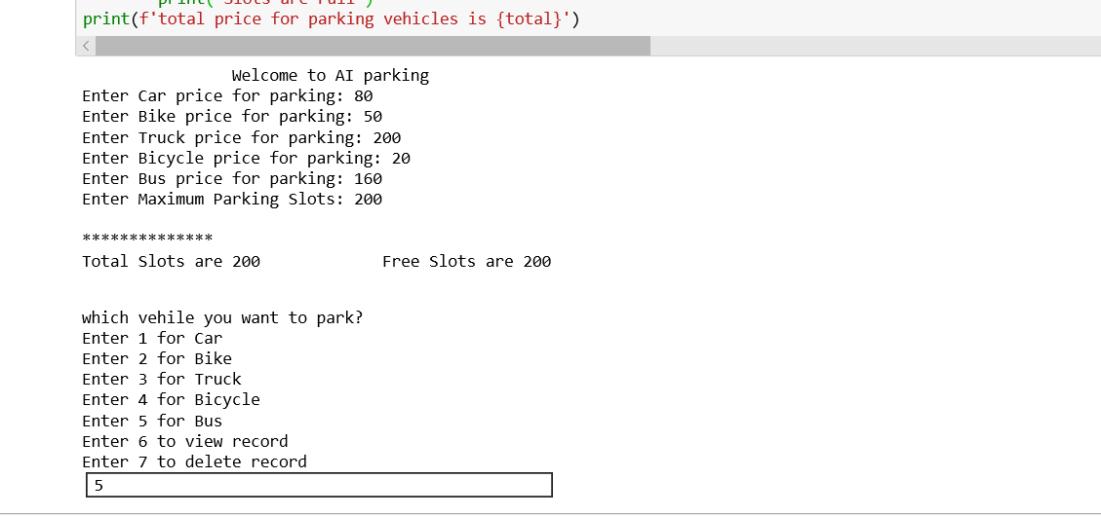

1. **When all the vehicle slots freed, the available slots becomes equal to the total slots present.**

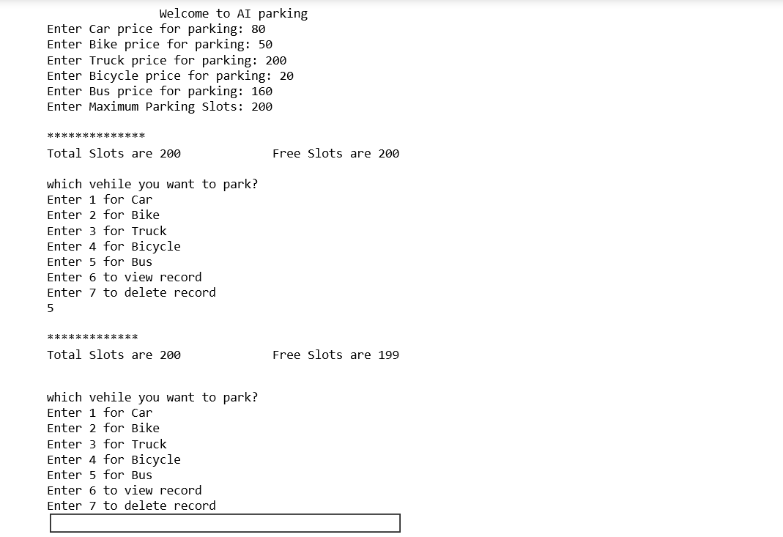

**5.The system also displays number of free slots and total slots.**

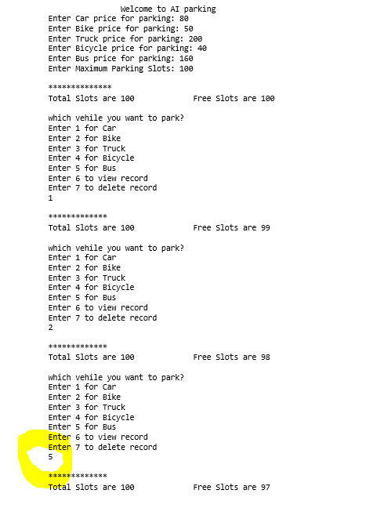

**6.The entire parking area can be vacated and number of free slots is updated to total slots.**

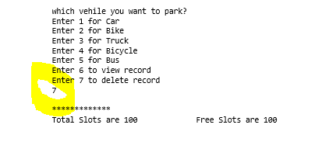

**DESCRIPTION OF WORK DIVISION:**

**-ALL THE MODULES IN THE PROGRAM WERE EQUALLY CONTRIBUTED BY BOTH OF US.**

**-APPENDICES and the report are done by both of us.**

**TECHNOLOGIES AND FRAMEWORK TO BE USED:**

**The program is created using python programming language. JUPYTER NOTEBOOK and ANACONDA prompt are used to create INTELLIGENT VEHICLE PARKING SYSTEM.**